**CST8257 Web Application Development**

Lab 4

# Objective

* Understand and use PHP session management.
* Define and use PHP common components

# Due Date

See Brightspace post for the due date. To earn 5 points, you are required:

1. Complete the lab as required.
2. Submit your lab work to the Blackboard before the due date.
3. Demo me your lab work during the following week’s lab session.

# Requirements

This application turns the single page application you developed in lab 3 into a 5-page application consisting of 5 pages; **Index.php**, **Disclaimer.php**, **CustomerInfo.php**, **DepositCalculator.php** and **Complete.php**.

1. Create a PHP page **Index.php** as shown below:

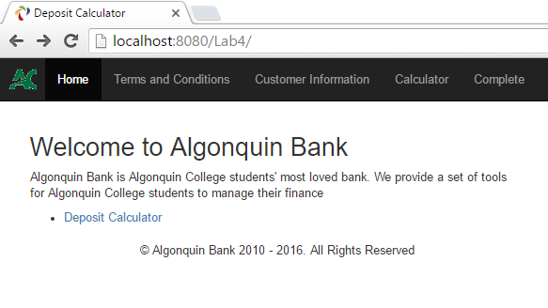

* Apache Web Server uses index.html or index.php as its default page. That is, when the page is not specified in the request URL, the web server will serve index.html or index.php (if index.html does not exist and php engine is installed) to the request.
* The page has a link to the **Disclaimer.php** page.

1. Create a PHP page **Disclaimer.php** as shown below:

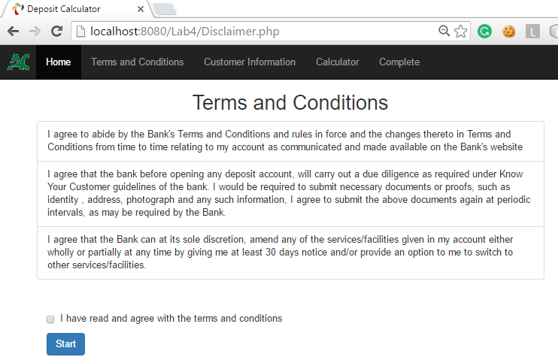

1. On this page, the user must check the checkbox “**I have read and agree …**” before click the **Start** button. Otherwise an error message will be displayed as shown below:

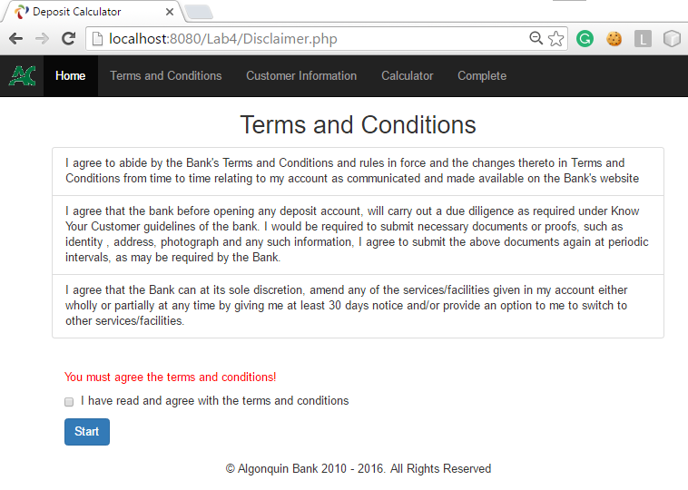

1. After the user checked the checkbox and clicks the **Start** button, a new page **CustomerInfo.php** page is shown below.

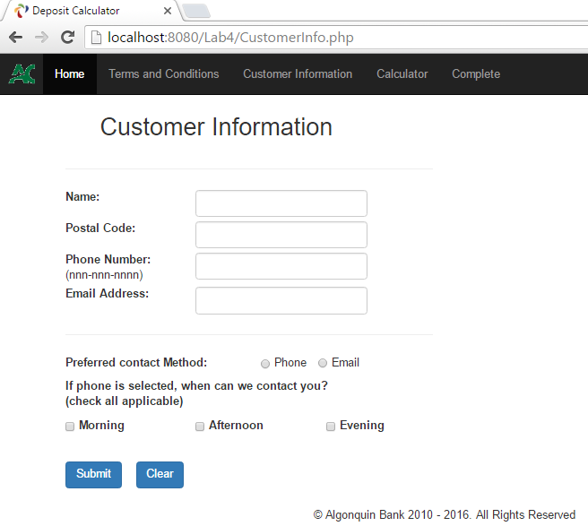

* If a user tries to access this page directly, bypassing the disclaimer page, by enter this page’s URL into the browser’s address field by click the top menu item **Customer Information**, the user should be redirected to the disclaimer page.
* This page collects the user’s contact information. The input fields subject to the same validation rules as in Lab 3, see Lab 3 for details.
* As in Lab 3, if the submitted form fails to pass the validation, the page displays the same web form again with error messages next to the invalid fields. For example:

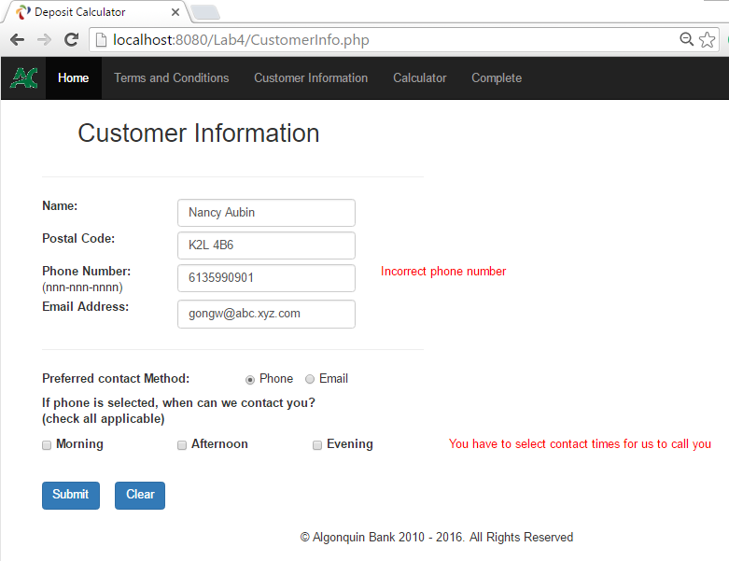

1. If the submitted customer information pass the validation, the user is presented with page **DepositCalculator.php** as shown below:

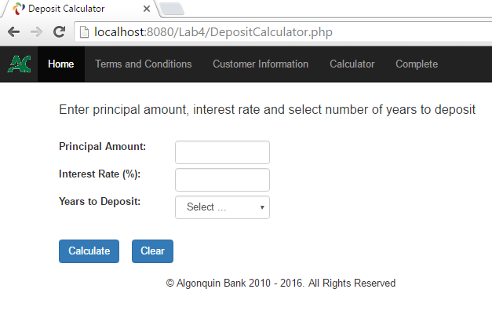

* If a user tries to access this page directly, bypassing the customer information page, by enter this page’s URL into the browser’s address field or by click the top menu item **Calculator**, the user should be redirected to the customer information page.
* The input fields subject to the same validation rules as in Lab 3, see Lab 3 for details.
* As in Lab 3, if the submitted form fails to pass the validation, the page displays the same web form again with error messages next to the invalid fields. For example:

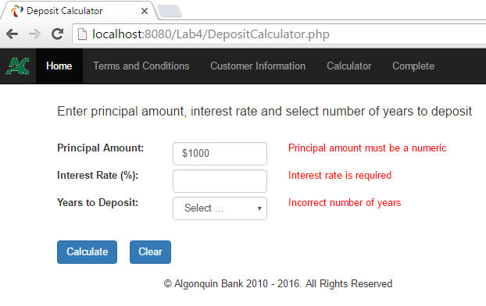

* If all fields pass the validation rules, the page displays the calculation results:

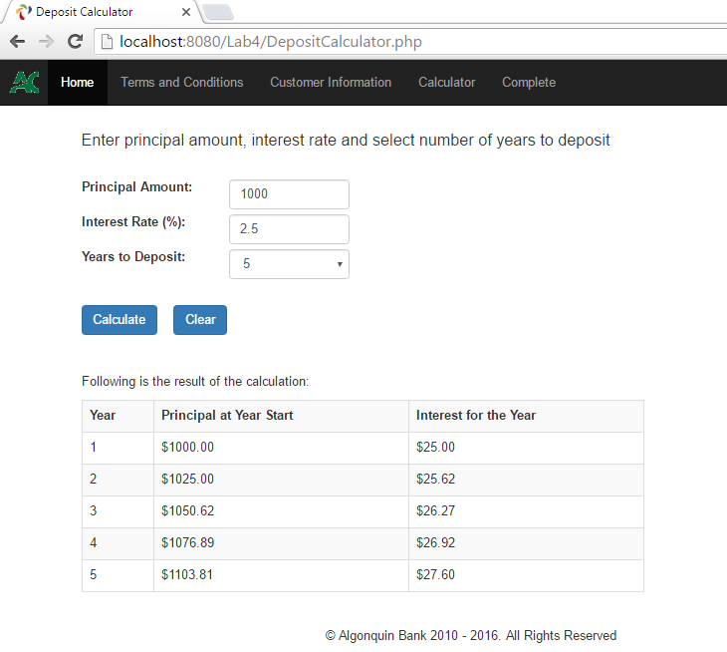

* The user should be able to modify the deposit data and click Calculate button to get the new results for the modified deposit data, subjecting to passing the rule validations.
* When Clear button is clicked the page should be the initial state as shown in the beginning of this section.

1. All pages of the application should have a top menu with the following menu items:

* Home – Links to **Index.php** page
* Terms and Conditions – Links to **Disclaimer.php** page
* Customer Information – Links to **CustomerInfo.php** page
* Calculator – Links to **DepositCalculator.php** page
* Complete – Links to **Complete.php** page
* At any time when the user clicks the menu item **Complete**, the application displays a personalized “Thank You Page” if the user entered the customer information, or a general “Thank You Page” if no customer information has been entered. See below:

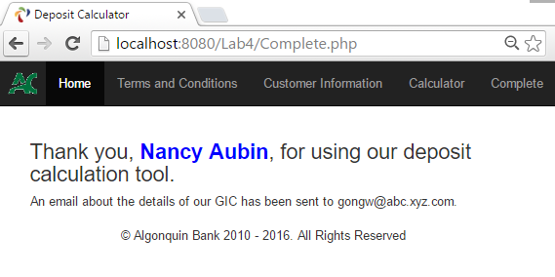

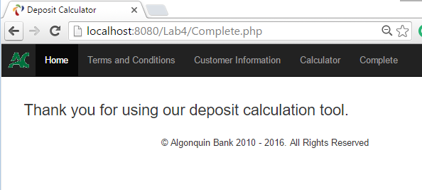

* Also, when the user clicks menu item Complete, all the customer information should be erased from the session so that the user’s personal data will not be available to others.

1. Additional requirements and Hints

* Download **AlgCommon.zip** file from Canvas. Unzip the folder AlgCommon into AMPPS’ web root folder. This folder is a NetBeans’ project containing all common elements, such as, Bootstrap, JQuery, and self-defined CSS classes, etc. used by this and remaining labs. Add this project to NetBeans by selecting menu item **File > Open Project …**

After adding to NetBeans, the project has the following structure:

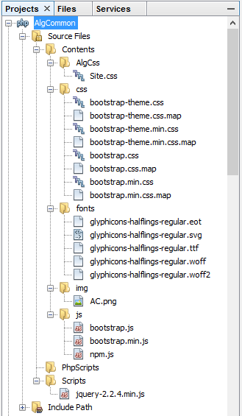

* The Lab 4 project in NetBeans should have the following structure:

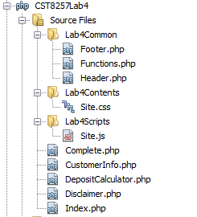

* Put all you php functions in **Functions.php** file. Include this file in those pages of the lab 4 which need to use one or more of the functions defined.
* Study and understand the following code snippet. Use it to create a sticky footer to your pages. It should be in **Footer.php** file and be included in all pages of the Lab 4 application.

<footer style="position: absolute; bottom: 0;

width: 100%; height: 60px; background-color: darkgreen;">

<div class="container">

<p style="text-align: center; padding: 10px; color: white;">

&copy; Algonquin College 2010 –

<?php date_default_timezone_set("America/Toronto"); print Date("Y"); ?>.

All Rights Reserved

</p>

</div>

</footer>

<script src="/Lab4/Lab4Scripts/Site.js" type="text/javascript"></script>

<script src="/AlgCommon/Scripts/jquery-2.2.4.min.js" type="text/javascript"></script>

<script src="/AlgCommon/Contents/js/bootstrap.min.js" type="text/javascript"></script>

</body>

</html>

* Study and understand the the following code snippet. Use it to create a top menu to your pages. It should be in **Header.php** file and be included in all pages of the Lab 4 application.

<!DOCTYPE html>

<html lang="en" style="position: relative; min-height: 100%;">

<head>

<title>Online Course Registration</title>

<meta charset="utf-8">

<meta name="viewport" content="width=device-width, initial-scale=1">

<link href="/AlgCommon/Contents/css/bootstrap.min.css" rel="stylesheet" type="text/css"/>

<link href="/AlgCommon/Contents/AlgCss/Site.css" rel="stylesheet" type="text/css"/>

</head>

<body style="padding-top: 50px; margin-bottom: 60px;">

<nav class="navbar navbar-default navbar-fixed-top navbar-inverse">

<div class="container-fluid">

<!-- Brand and toggle get grouped for better mobile display -->

<div class="navbar-header">

<button type="button" class="navbar-toggle collapsed" data-toggle="collapse"

data-target="#bs-example-navbar-collapse-1" aria-expanded="false">

<span class="sr-only">Toggle navigation</span>

<span class="icon-bar"></span>

<span class="icon-bar"></span>

<span class="icon-bar"></span>

</button>

<a class="navbar-brand" style="padding: 10px" href="http://www.algonquincollege.com">

<img src="/AlgCommon/Contents/img/AC.png"

alt="Algonquin College" style="max-width:100%; max-height:100%;"/>

</a>

</div>

<div class="collapse navbar-collapse" id="bs-example-navbar-collapse-1">

<ul class="nav navbar-nav">

<li class="active"><a href="Index.php">Home </a></li>

<li><a href="Disclaimer.php">Terms and Conditions</a></li>

<li><a href="CustomerInfo.php">Customer Information</a></li>

<li><a href="DepositCalculator.php">Calculator</a></li>

<li><a href="Complete.php">Complete</a></li>

</ul>

</div>

</div>

</nav>